|  |  |  |  |  |  |
| --- | --- | --- | --- | --- | --- |
| TT | Feature/Function | Assigned | Status | Time (days) | Pre |
| 1 | A| Prototype UI + Framework | B.Anh | 100% | 4 | - |
| 2 | B| Home/Products Page + Form | 1 | A |
| 3 | C| Cart Page + Form | 1 | A |
| 4 | D| Cart Feature (JS) | 2 | B, C |
| 5 | E| Login Page + Form | 1 | A |
| 5.1 | E’| Login JS | E |
| 6 | F| Register Page + Form | 1 | A |
| 6.1 | F’| Register JS | F |
| 7 | G| Manage Page + Form | B.Manh | -% | 1 | A |
| 7.1 | G’| Manage JS | -% | G |
| 8 | H| System Page + Form | -% | 1 | A |
| 8.1 | H’| System JS | -% | H |
| 9 | I| Product Detail Page | B.Anh | 100% | 1 | A |
| 10 | J| Finalize JS + Main Features | B.Anh | 70% | 3 | D, E, F, G, H, I |
| 11 | K| Finalize UI + Optional Features | B.Anh | 50% | Undefined  Min = 2 | B, C, D, E, F, G, H, I |
| L| Project Inspect + Bug Fix |

Overall: 70%

**1.Prototype**

Main Pages

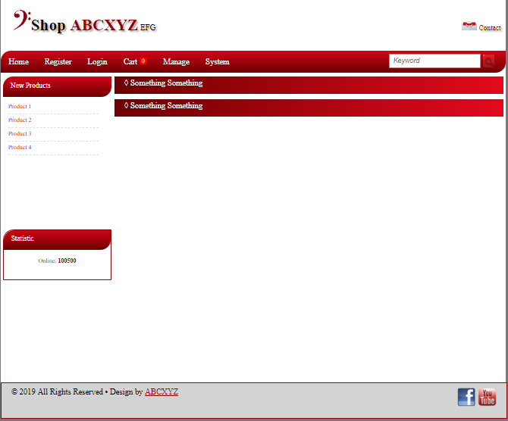

Sidebars - NewProducts.html + Statistic.html

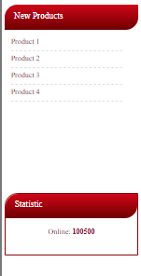

**2.Home/Product Page - home.html**

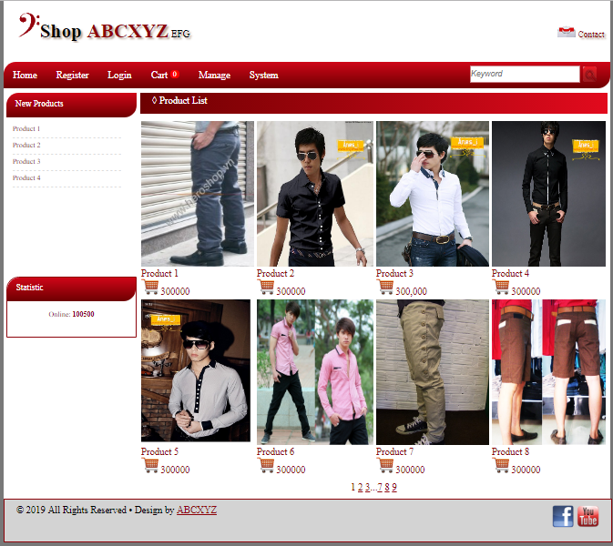

**3.Cart Page - cart.html**

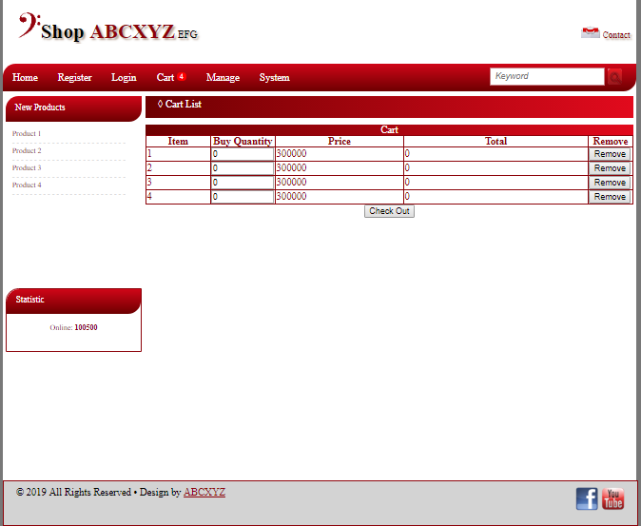

**4.Login Page**

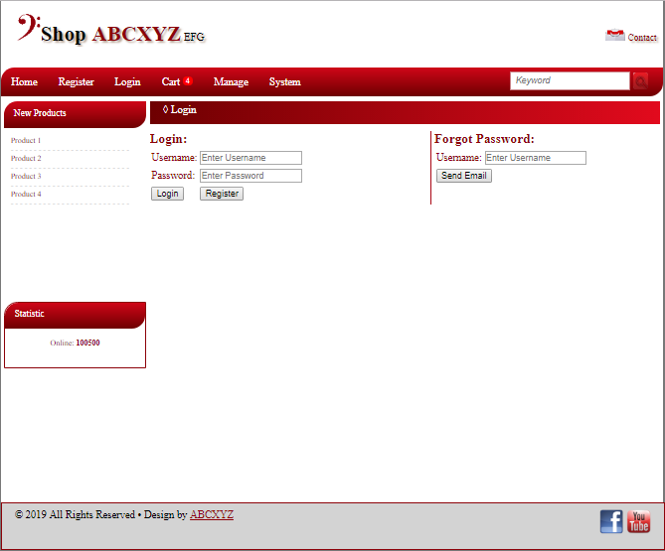

**5.Register Page - register.html**

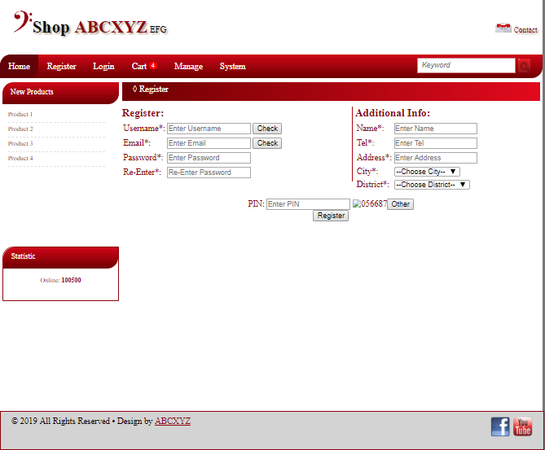

**6.Manage Page - Manage.html**

**7.System Page - System.html**